📊 Excel Project – Finance Domain
Investment & Investor Preference Analysis

Investment & Investor Preference Analysis
Introduction
About the Project
- The project focuses on individual investment behavior.
- It helps understand different investment avenues.
- It analyzes investors based on age, gender and investment preferences.
- It studies investment objectives and reasons.
- Excel is used to convert raw data into meaningful insights.
Explanation:
“The main purpose of this project is to understand how people make investment decisions and which investment options they prefer.”

Objectives
- Analyze the investor dataset.
- Identify the most preferred investment avenue.
- Analyze investment preferences by gender.
- Study age groups and investment choices.
- Understand investors' savings objectives.
- Analyze monitoring frequency.
- Compare Equity and Mutual Fund preferences.
- Create Pivot Tables and charts.
- Develop an interactive Excel dashboard.
- Generate useful financial insights.
Explanation:
“The objective is not only to count investors but also to identify patterns in their investment behavior.”
Dataset Description
Important Fields
Field | Description
Age | Age of investor
Gender | Male/Female
Investment Avenue | Type of investment
Savings Objective | Purpose of saving
Investment Duration | Period of investment
Reason for Investment | Reason for selecting an option
Expected Return | Expected return from investment
Monitoring Frequency | How often investment is monitored
Explanation:
“These fields help us analyze investors from demographic, behavioral and financial perspectives.”
Slide 5 – Data Cleaning & Preparation
Excel Steps Used
- Removed duplicate records.
- Checked missing values.
- Standardized categories.
- Checked incorrect data entries.
- Created age groups.
- Verified investment categories.
- Converted data into an Excel Table.
- Prepared data for Pivot Tables.
Explanation:
“Before performing analysis, I cleaned and organized the raw dataset so that the results would be accurate and consistent.”

Slide 6 – Basic Analysis
Key Analysis
- Total number of investors
- Gender-wise investor distribution
- Average age
- Most preferred investment avenue
- Number of investors in:
  - Mutual Funds
  - Equity Market
  - Fixed Deposits
- Top savings objectives
- Regular investment monitoring
Excel Functions Used
COUNT / COUNTA
COUNTIF
AVERAGE
SUM
IF
Explanation:
“Basic analysis gives us an overall understanding of the investor population and their investment behavior.”
Investment Avenue Analysis
Investment Options
Mutual Funds
Equity Market
Fixed Deposits
Public Provident Fund
Gold
Others
Suggested Chart:
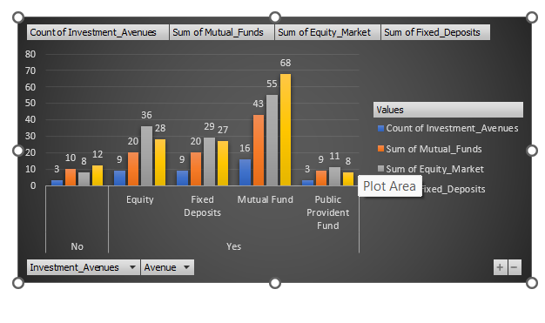 Investors by Investment Avenue
Explanation:
“This analysis helps identify which investment avenue is most popular among investors and which options have comparatively lower participation.”
Investment Avenue vs Gender
Pivot Table
Rows: Investment Avenue
Columns: Gender
Values: Count of Investors
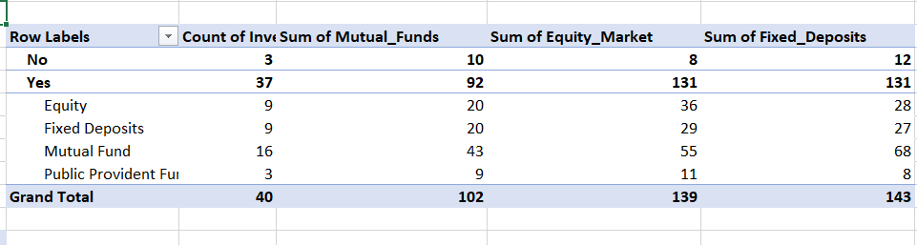
Age Group vs Investment
Create Age Groups
Pivot table
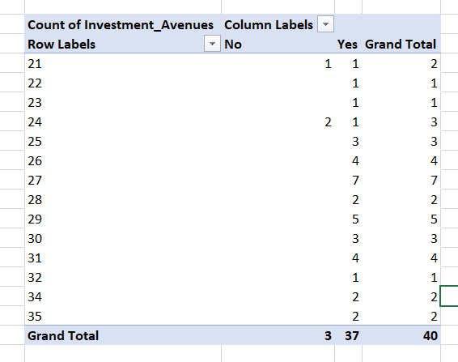
Rows: Age Group
Columns: Investment Avenue
Values: Count of Investors
Suggested Chart:
📊 Stacked Column Chart
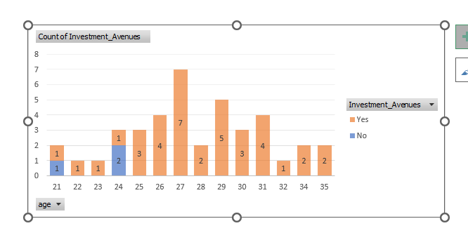
Explanation:
“Age plays an important role in investment decisions. Younger investors may prefer growth-oriented investments, while older investors may prefer comparatively stable options.”
Savings Objectives
Analyze Top Objectives
Possible objectives include:
- Retirement Planning
- Wealth Creation
- Education
- Emergency Fund
- Tax Saving
- Regular Income
Suggested Chart:
📊 Bar Chart – Savings Objective Distribution
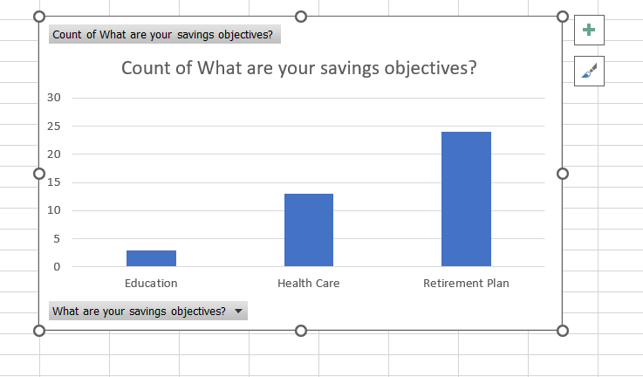
Explanation:
“This analysis identifies why investors save money and which financial goals are most important to them.”
Investment Duration Analysis
Duration Categories
- Short Term
- Medium Term
- Long Term
Analyze:
Investment Duration vs Investment Avenue
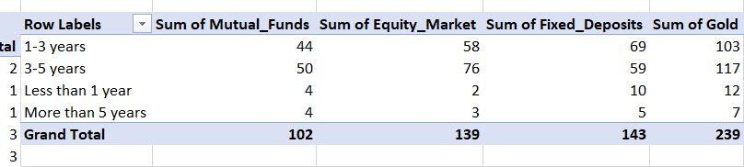
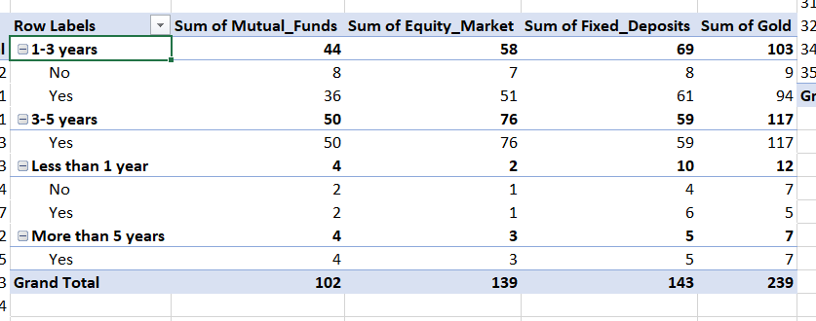
Explanation:
“This analysis helps understand whether investors choose different investment products depending on how long they plan to invest.
Investment Monitoring Frequency
Monitoring Categories
- Daily
- Weekly
- Monthly
- Quarterly
- Rarely
Analysis:
Monitoring Frequency vs Age Group
Suggested Chart:
📊 Column Chart
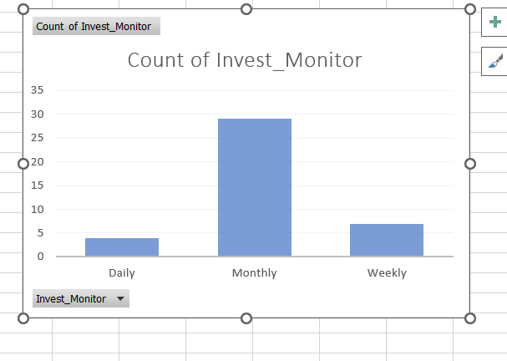
Explanation:
“Monitoring frequency shows how actively investors track their investments. It can also be compared with age to identify behavioral differences.”
– Equity vs Mutual Funds
Compare:
Equity Market
vs.
Mutual Funds
Analyze:
- Number of investors
- Reasons for choosing
- Expected returns
- Investment duration
- Risk preference
Explanation:
“Equity and Mutual Funds are popular investment avenues, but investors may choose them for different reasons. This comparison helps understand their preferences.”
– Expected Return Analysis
Analysis
Use Conditional Formatting to highlight:
🟢 High Expected Return
🟡 Medium Expected Return
🔴 Low Expected Return
Excel Feature:
Conditional Formatting → Color Scales
Explanation:
“Conditional formatting makes it easier to identify investors expecting higher returns and helps visualize the differences in expectations.”
– Finance Dashboard
📈 Investor Investment Dashboard
KPI Cards
Total Investors
Average Age
Top Investment Avenue
Top Savings Objective
Most Common Monitoring Frequency
Dashboard Charts
- Investment Avenue Distribution
- Gender-wise Investment
- Age Group vs Investment
- Savings Objectives
- Investment Duration
- Monitoring Frequency
Slicers
🔹 Gender
🔹 Age Group
🔹 Investment Avenue
🔹 Investment Duration
Explanation:
“The dashboard brings all important findings into one place. Slicers make the dashboard interactive, allowing users to filter the analysis according to gender, age group or investment type.”
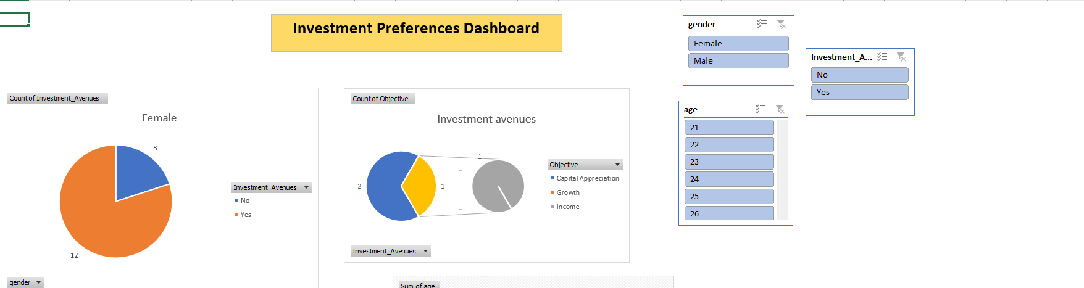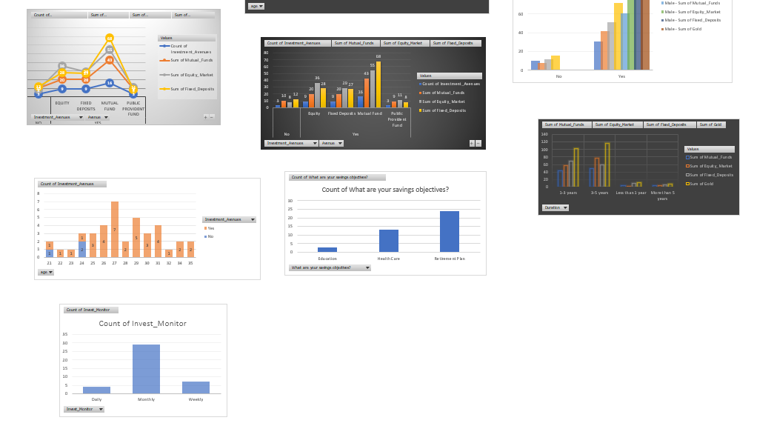
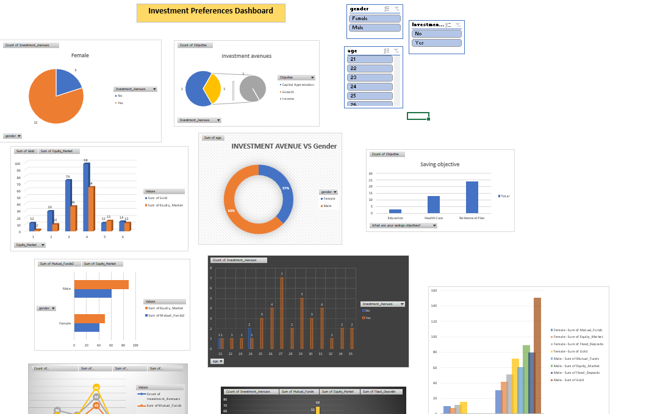

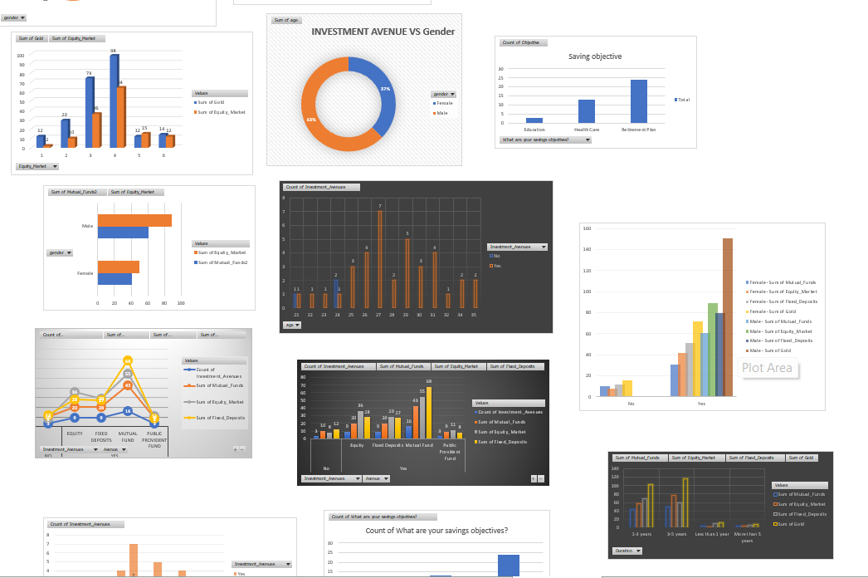

Insights from the Analysis
- Identified the most preferred investment avenue.
- Compared investment behavior between male and female investors.
- Identified investment preferences across different age groups.
- Found the most common savings objectives.
- Studied investment duration and investment type.
- Analyzed how frequently investors monitor their investments.
- Compared Equity Market and Mutual Funds.
- Identified investors with higher expected returns.
Important: Replace these statements with your actual Excel results/numbers from the dataset.
Business/Financial Recommendations
Recommendations
- Financial institutions should offer products according to different age groups.
- Investment platforms can provide personalized investment recommendations.
- Investors should diversify their portfolios.
- Educational content can help investors understand risk and return.
- Regular monitoring can help investors track investment performance.
- Financial products can be designed according to investors' savings objectives.
Explanation:
“Based on the analysis, financial companies can use investor preferences to create more personalized investment products and services.”
Conclusion
“The project demonstrates how Microsoft Excel can be used to analyze financial and investment data. Using formulas, Pivot Tables, charts, conditional formatting and an interactive dashboard, we can identify investment patterns and investor preferences. The analysis can help financial organizations understand their customers and make better data-driven decisions.”
THANK YOU!

